**Effect of Solvent-Induced Swelling on Exciton Transport in Conjugated Polymer Nanoparticles**

Louis C. Groff, Yifei Jiang, Xiaoli Wang, and Jason D. McNeill

**KEYWORDS**

Diffusion, Energy Transfer, Modeling, Decay Kinetics, Anisotropy

**ABSTRACT**

The effect of solvent-induced swelling on fluorescence quenching and exciton dynamics of conjugated polymer nanoparticles was investigated by steady-state and time-resolved fluorescence spectroscopy. Time-resolved fluorescence anisotropy decay was measured to determine the rate of exciton hopping for both polymers, which gives insight into the number of exciton hops that occur within the fluorescence lifetime (~32 for swelled PFBT CPNs versus ~3 for PFBT in THF). The results indicate highly efficient quenching in poor solvent conditions, due to the tightly-packed chain conformation of the nanoparticles, which leads to an increase in exciton hopping rate by up to ~60 times that of the free polymer. This was reversed completely at high THF concentrations, where the system is comprised of linear polymer chains with a reduced hopping rate. A discrete cubic lattice model incorporating exciton diffusion and energy transfer was employed to elucidate the relationships between solvent-induced swelling, quenching efficiency, and decay kinetics for both systems. The simulation results show good agreement with experimental data at low to moderate THF concentrations, which provides a complimentary way to probe exciton hopping rates for those samples. It is hypothesized that the hopping rate has a significant effect on measured quenching efficiency and fluorescence quantum yield for both polymers, which has implications for both device and imaging applications.

**INTRODUCTION**

Conjugated polymers (CPs) have, and continue to garner attention, owing to their applications to low-cost photovoltaic and light emitting diode technologies.1,2 Conjugated polymer nanoparticles (CPNs) are well-suited biological imaging applications, given their extraordinary photostability, brightness, and two-photon cross-sections, as well as their ability to be bioconjugated in order to facilitate cellular uptake.3-9 CPs are also of interest as a model multi-chromophore system,10 and model system for coupled spins.11 Excitons in CPs provide a model system for confined, energetically disordered quantum mechanical spin glasses.12,13 In order to better utilize conjugated polymers for these applications, it is necessary to further investigate the complex photophysics exhibited by these materials, as they are highly dependent upon polymer structure and processing conditions.

The principal neutral photoexcitation in conjugated polymers is the Frenkel exciton.14,15 In this case, excitations are electronically coupled between one or more chromophores, each consisting of one or more monomer units. Exciton diffusion occurs via transition dipole mediated Förster resonance energy transfer (FRET) to nearby chromophores.16 Energy transfer in conjugated polymers typically occurs via incoherent, diffusion-like processes,17-19 dispersive transport,20 and in certain cases, by long-range coherent transport.21 Conjugated polymers exhibit highly efficient Förster transfer to both dye and polymer dopants, providing red shifted emission for use in imaging applications.22-24 Excitons may be quenched by energy transfer to dopant species, nonfluorescent defect sites, photogenerated hole polarons, or aggregate species, including H- and J-aggregates, excimers, and exciplexes.25-30 The number of aggregate species produced in conjugated polymers depends upon the solvent environment, which has a substantial impact on the conformations of the individual polymer chains, and as such, impacts the number of chromophores per unit volume of polymer, or chromophore density. Abrupt introduction into a poor solvent environment such as water results in chain collapse, where the polymer chains adopt conformations that minimize external forces resulting from surface tension, resulting in either spherical or ellipsoidal nanoparticles, depending on size.31 The tightly-packed structures of CPNs result in a dramatic increase in chromophore density, or conversely, a decrease in interchromophore distance. Given the *R*-6 distance dependence of Förster energy transfer efficiency, it follows that a dense matrix of chromophores individually separated by a few nanometers facilitates exciton transfer between chromophores. As the fraction of organic solvent is increased, the densely-packed polymer chains swell as a result of solvent inclusion into the polymer matrix, which gradually increases the interchromophore distance, reducing FRET efficiency between nearby chromophores. Further analysis into changes in the hopping energy transfer rate allow for understanding of how the hopping rate affects photophysical parameters such as lifetime and quenching efficiency.

From such analysis, it is also possible to determine the relative measure of how many exciton hops occur within the mean excited state lifetime. Conventional lifetime measurements allow for the measurement of general rates of exciton decay, but provide little information as to the events prior to decay. While it is generally accepted that excitons move throughout the polymer structure via multiple energy transfer, the distance scale over which these events occur is not as extensively studied (whether motion occurs as more frequent, smaller hops versus less frequent, longer hops). Previous work on dye-doped PFBT CPNs resulted in the determination of the distance scale over which an exciton travels within the fluorescence lifetime of the polymer (~12 nm), as well as accounting for the added complexity of exciton decay kinetics that result from intrinsic defects present in the polymer structure, leading to a general reduction, and a greater distribution of lifetimes.22 We wish to further this idea by assessing how exciton mobility impacts the distribution of lifetimes, overall decay kinetics, and quenching efficiency.

To this end, time-resolved fluorescence anisotropy decay is employed, which provides insight into the processes that cause depolarization of emission when a sample is initially excited with a linearly polarized source, and the emission at several different polarization angles is analyzed. In many cases, the causes of fluorescence depolarization are due to rotational degrees of freedom (e.g. within a macromolecule) or rotational diffusion of smaller molecules.32,33 In cases such as CPNs where rotation is limited due to particle size and solvent viscosity, depolarization resulting from rotation occurs on time scales much greater than that of the mean exciton lifetime. Hence, the majority of dynamics that result in depolarization of emission within the exciton lifetime can be ascribed to exciton transfer events to nearby chromophores with randomly oreiented transition dipole moments. The resulting polarized intensity decays can be used to construct time-resolved anisotropy decays, which aid in quantifying the number of exciton hopping events that occur within the mean exciton lifetime (i.e. the exciton hopping rate) by analysis of the anisotropy decay kinetics in conjunction with conventional lifetime data.34

**EXPERIMENTAL METHODS**

**Materials.** The copolymer poly[(9,9-dioctylfluorenyl-2,7-diyl)-*co*-(1,4-benzo-{2,1',3}-thiadiazole)] (PFBT, MW 10,000, polydispersity 1.7), and the poly(phenylene vinylene) derivative poly[2-methoxy-5-(2-ethylhexyloxy)-1,4-phenylenevinylene] (MEH-PPV, MW 200,000, polydispersity, 4.0) were purchased from ADS Dyes, Inc. (Quebec, Canada). The fluorescent dye fluorescein was purchased from Life Technologies (Invitrogen, Eugene, OR). The fluorescent dye Lucifer Yellow CH dipotassium salt (LY, 1 mg/mL in water), solvent tetrahydrofuran (THF, anhydrous, inhibitor-free, 99.9%) and sodium hydroxide (SigmaUltra, minimum 98%) were purchased from Sigma-Aldrich (Milwaukee, WI). All materials were used as provided without further purification.

**Nanoparticle Preparation.** The preparation of fluorescent nanoparticles was performed via a previously described nano-precipitation method.35 The conjugated polymers PFBT and MEH-PPV were dissolved in THF by gentle agitation and prepared at a concentration of 1000 ppm. An aliquot of each stock solution was used to prepare precursor solutions at 20 ppm. A 2 mL quantity of a given precursor solution was rapidly added into 8 mL of deionized water under bath sonication at a frequency of 40 kHz and room temperature. Removal of THF was accomplished by the following procedure. Nanoparticle suspensions were placed in a vacuum oven under nitrogen flow for 8 hours at room temperature in order to remove enough THF to prevent bumping during the subsequent evacuation step. Nitrogen flow was ceased and samples were pumped down to an atmosphere of <10 torr using a two-stage rotary vane pump. The samples were heated at ~40 °C for 6-7 hours to remove most of the remaining THF. The total volume of liquid was reduced by typically 60% during the vacuum evaporation process. The aqueous samples were vacuum filtered through a glass fiber prefilter to remove larger aggregates and a 0.1 µm PVDF membrane filter (Millipore). The resulting suspensions are clear (not turbid) and stable for months with no visible signs of aggregation.

**Characterization Methods.** UV-Vis absorption spectra were acquired using a Shimadzu UV2101PC scanning spectrophotometer with 1 cm quartz cuvettes. Fluorescence spectra and fluorescence quantum yield were measured using a commercial fluorimeter (Quantamaster, Photon Technology International) using 1 cm quartz cuvettes.

Picosecond fluorescence lifetimes and fluorescence anisotropy decay (FAD) were measured under nitrogen using a home-built setup for time-correlated single photon counting (TCSPC) spectroscopy operating in reverse mode. Frequency doubled pulses (420 nm) from a passively mode-locked Ti:Sapphire laser (Coherent Mira 900, 840 nm pulses, ~150 fs pulsewidth) were used as the excitation source for the nanoparticle samples. Sample emission was collected with perpendicular geometry to the excitation source after passing through a 460 nm long pass filter, and a calcite Glan-Taylor polarizer (Thorlabs, GT10-A) oriented either parallel (0°), perpendicular (90°), or at magic angle (55°) to the vertically polarized excitation pulses. All three polarization angles were utilized for FAD, magic angle polarizer orientation was adopted for TCSPC. The output of a single photon avalanche photodiode (APD, id Quantique, id100-50) was used as the start timing pulse for a time-to-amplitude converter (TAC, Canberra Model 2145), and the output of a fast PIN diode (Thorlabs, DET210) was used as the stop pulse, in a standard reverse-mode configuration.32,36 The excitation power was attenuated (usually between ~300 µW and 1 mW) to maintain a count rate of ~400 kHz as measured at the APD. The analog TAC output was digitized using a multi-channel analyzer (FastComTec, MCA-3A). Before and after each measurement, an instrument response function (IRF) was measured using scattered excitation light from a dilute suspension of polystyrene microspheres. The width of the IRF was determined to be ~70 ps (fwhm). Typical peak signal-to-noise ratios (SNR) were between 200:1 (80%-100% THF samples) and 500:1 (IRF and low-mid % THF samples). The reported information was collated from a total of two samples per concentration of THF, and 3-5 scans per sample. Intensity decays were collected for 5-20 minutes to obtain the above mentioned SNR values, depending on the lifetime of the sample.

**Swelling Procedure.** In addition to nanoparticles in water and polymer in THF, swelled nanoparticle samples were prepared by diluting an aliquot of concentrated nanoparticle suspension with the appropriate volume of water, followed by slowly adding THF to produce 3 mL of suspension with volume ratios of THF/water between 0.2 and 0.95. Each sample was gently agitated to ensure solution homogeneity. The sample absorbance was kept at or under ~0.05 (~0.02 for 95% THF). Samples were purged with nitrogen for ~2 minutes, limiting THF losses for higher % THF samples.

**RESULTS/DISCUSSION**

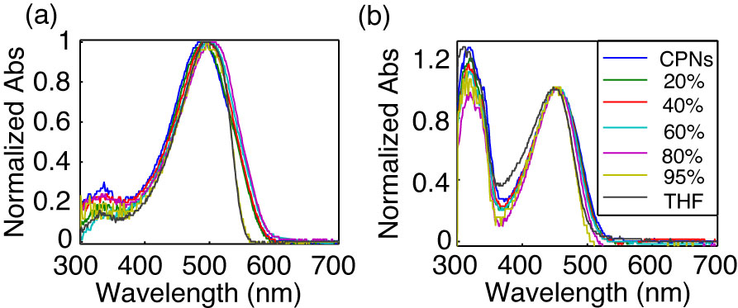

**Fig. 1.** Normalized absorption spectra of (a) MEH-PPV and (b) PFBT at varying volume % THF.

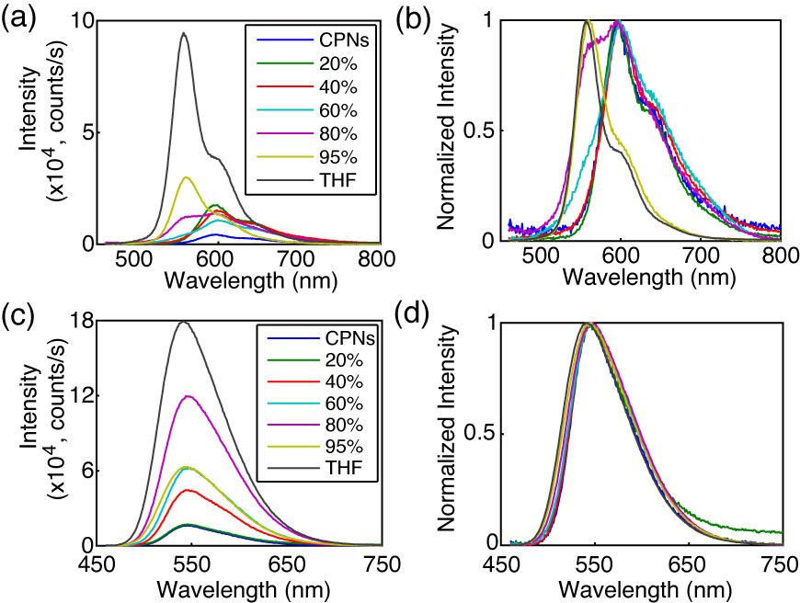

**Fig. 2.** (a,c) Absolute and (b,d) normalized emission spectra of MEH-PPV (top) and PFBT (bottom) at varying volume % THF.

**Effect of solvent composition on UV-vis and fluorescence.** The UV-vis and fluorescence spectra of PFBT and MEH-PPV as a function of solvent composition are given in Figs. 1 and 2. The absorption spectra of PFBT maintain a similar shape with increasing THF, with a ~5 nm total blue shift, and slight broadening of the THF sample spectrum. The emission spectra show a monotonic increase in fluorescence intensity as the concentration of THF increases, and the spectra also exhibit a blue shift ~5 nm over the course of increasing THF. The absorption spectra of MEH-PPV maintain a similar shape as THF concentration is increased, though the 95%-100% THF spectra are narrower than the spectra of the other samples. The absorption peak of MEH-PPV red shifts a total of ~15 nm from 0%-80% THF, and then blue shifts ~7 nm for the 95%-100% THF samples. The emission peak blue shifts a total of ~40 nm as THF composition is increased, and it is evident from ~40% THF to 80% THF that there are two phases present in solution by the increase in intensity of the ~560 nm shoulder on the spectrum, and the reduction in intensity of the ~600 nm shoulder of the spectrum as % THF increases. An approximate isosbestic point can be seen at ~580 nm over the concentration range of ~60%-80% THF.

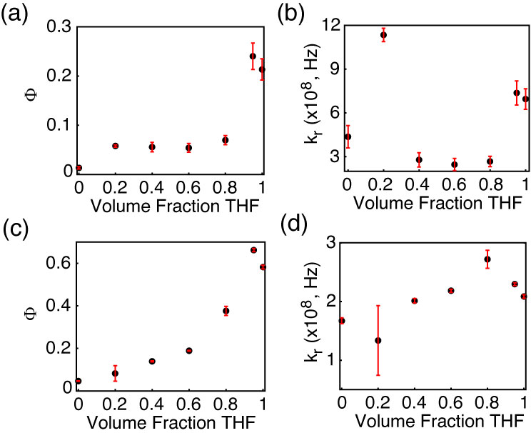

**Fig. 3.** (a,c) Fluorescence quantum yield and (b,d) radiative rate vs. THF volume fraction for MEH-PPV (top) and PFBT (bottom).

The fluorescence quantum yields ( and calculated radiative rates, where the radiative rate is defined as are given in Fig. 3. The quantum yield of PFBT increases monotonically with increasing THF. However, MEH-PPV shows an initial intensity increase from 0%-20% THF, followed by the quantum yield staying relatively consistent from 20% to 80% THF, then increasing at higher %THF. The higher quantum yield of the 95% sample relative to the polymers in THF is ascribed to the uncertainty in the absorbance at such low concentrations of PFBT and MEH-PPV. The quantum yield remains relatively constant for MEH-PPV at moderate THF concentrations, and can be ascribed to the trade-offs in intensity between the ~560 nm shoulder and the ~600 nm shoulder of the spectrum. The radiative rate varies over a factor of ~2 for PFBT and a factor of ~4 for MEH-PPV over the course of increasing THF concentration.



It is possible that the results outline in Figs. 2 and 3 indicate that transition dipole coupling is somewhat stronger for MEH-PPV compared to PFBT. This is made more evident by closer analysis of the spectral data. Transition dipole coupling leads to a pronounced red shift in both the absorption and emission spectra, which is observed in the MEH-PPV emission spectra, while the PFBT spectral shift is small in both the absorption and emission spectra. It is possible that the lesser red shift in the absorption spectra of MEH-PPV can be explained by a smaller number of chromophores in MEH-PPV having their transition dipoles strongly coupled compared to the total number of chromophores per CPN.

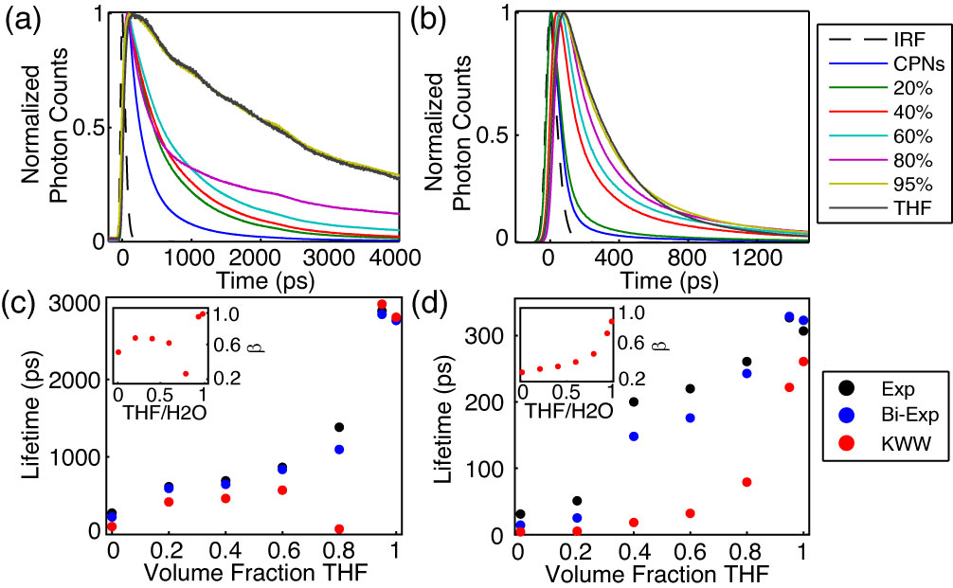

**Fig. 4.** (a,b) Normalized fluorescence intensity decays, and (c,d) lifetimes resulting from single exponential, bi-exponential weighted average, and KWW trial functions with stretch parameter ** insets) versus THF volume fraction for PFBT and MEH-PPV, respectively.

**Table 1.** Summary of bi-exponential lifetime Data for MEH-PPV and PFBT CPNs, including weighted amplitudes and individual exponential time constants.

|  |  |  |  |  |  |  |  |  |
| --- | --- | --- | --- | --- | --- | --- | --- | --- |
| **%(v/v) THF** | **MEH-PPV** | | | | **PFBT** | | | |
| ***A1*** | ***1* (ps)** | ***A2*** | ***2* (ps)** | ***A1*** | ***1* (ps)** | ***A2*** | ***2* (ps)** |
| **0** | 0.964 | 9 | 0.036 | 152 | 0.593 | 88 | 0.407 | 421 |
| **20%** | 0.931 | 14 | 0.069 | 176 | 0.513 | 261 | 0.487 | 941 |
| **40%** | 0.734 | 56 | 0.266 | 401 | 0.507 | 277 | 0.493 | 1029 |
| **60%** | 0.749 | 74 | 0.251 | 482 | 0.554 | 364 | 0.446 | 1427 |
| **80%** | 0.752 | 120 | 0.248 | 616 | 0.649 | 231 | 0.351 | 2700 |
| **95%** | 0.795 | 218 | 0.205 | 761 | 0.024 | 234 | 0.976 | 2905 |
| **100%** | 0.949 | 271 | 0.051 | 1287 | 0.006 | 266 | 0.994 | 2778 |

**Picosecond Time-Resolved Fluorescence Spectroscopy.** Reverse-mode TCSPC obtained at magic angle to the excitation source was employed to measure the excited state decay kinetics of both CPN systems over the range of solvent composition. The trial functions employed during iterative reconvolution fitting analysis were single exponential, bi-exponential, and the Kolrausch-Williams-Watts (KWW) function or stretched exponential, given by , where ** is the stretch parameter. Values for ** are typically between ~0.3 and 1, where lower values correspond to a broader distribution of lifetimes for a given sample, and **   corresponds to a single exponential lifetime.37 The fits to all three trial functions converged for all samples. With exception of PFBT in THF which was fit best by a single exponential, the remaining intensity decays fit best to bi-exponential and KWW trial functions. The representative intensity decays for each sample, along with the respective time constants and **versus %THFare given in Fig. 4. The lifetimes for both systems follow a generally increasing trend as THF concentration increases. The lifetimes of the CPN samples in water are smaller than previously reported (~275 ps versus ~700 ps previously for PFBT), but can be ascribed to a more complete THF removal process, as evidenced by the accompanying reduced quantum yield ( = 0.04 versus  = 0.14 previously for PFBT). ** generally increases for both systems as the fraction of THF increases, beginning at ~0.3 for CPNs in water and increasing monotonically to ~0.8 for MEH-PPV in THF, indicating that MEH-PPV in solution exhibits complex exponential decay kinetics. Conversely, ** for PFBT increases from ~0.6 for CPNs in water to unity in THF. The trends in ** are hypothesized to be due to the rate of exciton diffusion and energy transfer to quenchers at each solvent composition, where *  *< 0.9 is indicative of an increased rate of exciton transfer to quenchers, which contributes to the breadth of the lifetime distribution, and a value of unity is indicative of little or no energy transfer to a quenching species.30 A dramatic decrease in* * is observed for PFBT from ~0.7 at 60% THF to ~0.3 at 80% THF, and is indicative of a sudden increase in the distribution of exciton lifetimes. This is further explained by a closer inspection of the bi-exponential results discussed below.



A breakdown of the bi-exponential fit results is given in Table 1. It can be seen starting at 40% THF for MEH-PPV and 80% THF for PFBT that the individual exponential time constants approximately reproduce the nanoparticle lifetime in 1, and the free polymer lifetime in 2. Thus, the lifetime analysis provides evidence that might suggest a two state-like system. For MEH-PPV, the long time constant continues to increase over the course of THF addition, and the amplitudes do not change appreciably except for MEH-PPV in THF. Conversely, the time constants remain approximately the same for PFBT between 80% – 100%, and the amplitude corresponding to the long time constant increases from 80-100% THF. A more detailed discussion of the implications of this analysis will be discussed in a later section.

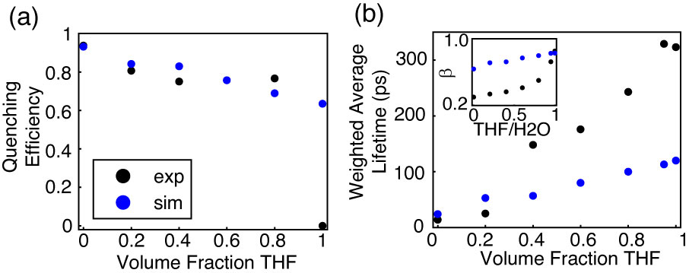

**Fig. 5.** Comparison of simulated (blue) and experimental (black) (a) quenching efficiency, (b) average lifetime, and (inset) KWW stretch parameter *ß* versus THF volume fraction for MEH-PPV.

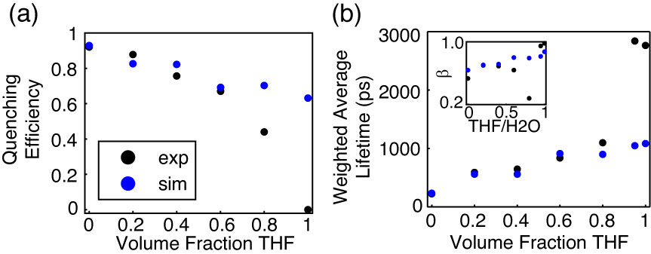

**Fig. 6.** Comparison of simulated (blue) and experimental (black) (a) quenching efficiency, (b) average lifetime, and (inset) KWW stretch parameter *ß* versus THF volume fraction for PFBT.

**Lattice Swelling Model.** Exciton transport in conjugated polymers can be described via a multiple energy transfer process where excitons hop between chromophores along or on adjacent chains prior to radiative/nonradiative decay or FRET to intrinsic quenching species (e.g. nonfluorescent chemical defects or redshifted aggregate chromophores). A tightly-packed polymer chain network such as that of a CPN facilitates energy transfer to both chromophores and quenchers, resulting in efficient fluorescence quenching due to the high mobility of excitons in conjugated polymers, as well as a significantly reduced exciton lifetime (np ~ 275 ps versus poly ~ 2.8 ns for PFBT). Gradual introduction of a good solvent results in swelling of the polymer network, which gradually increases the physical spacing between individual chains and any quenching species which may be present on each chain. Due to the R-6 distance dependence of FRET, increases in chromophore spacing lead to a reduction in both interchain and intrachain energy transfer events as the number of nearest neighbor chromophores are reduced, which limits exciton mobility, and reduces quenching by intrinsic species.

A discrete lattice model based on previous iterations of an exciton diffusion/energy transfer model was employed in order to model the effect of solvent-induced swelling on exciton quenching and decay kinetics using a numerical random walk algorithm. This approach was previously utilized to model exciton diffusion and energy transfer in dye-doped nanoparticles, both on a discrete cubic lattice,30 and on a spherical continuum including quenching by defects.22 This method was also employed to model fluorescence centroid fluctuations due to polaron motion on single CPNs.38 In this model, each polymer is assumed to be regular, a cubic particle is assumed, with lattice spacing determined by the cube root of the volume of one chromophore, assumed to be comprised of two monomer units. Excitons hop between nearest neighbor chromophores, and the energy transfer rate is set to reproduce the observed exciton diffusion length from previous work of *LD* = 12 nm, which is assumed for both polymers.22 The exciton hopping probability for a random walk in the absence of swelling is given by , where *t* is the time step, andD is the exciton diffusion constant given by , where  is the lifetime of the polymer in good solvent.

In order to account for solvent-induced swelling, we assume that swelling occurs in a similar fashion to other structurally similar polymers such as polystyrene (PS). As such, increases in the lattice spacing were calculated from data on dye-loaded PS beads swelled with THF.39 In swelling the lattice, the nanoparticle size increased by a swelling factor initially derived from the ratio of swelled/unswelled nanoparticle volumes, given by, where *d* is the swelled lattice spacing, and *x* is the original nanoparticle lattice spacing, calculated to be 1.2 nm for PFBT, and 0.9 nm for MEH-PPV, respectively. The hopping probability was reduced by a factor given by , using the assumption that the hopping probability as a function of lattice spacing is proportional to , where *k* is a constant, typically between 2-4 for excitonic systems, assumed to be 2 for these polymers.15 The time step size was adjusted so that initially, . An integer number of quenchers replace chromophores on the lattice, each with an assumed quenching radius of 4 nm, similar to that of a perylene red dye molecule. The mean number of quenchers per nanoparticle is determined by adding quenchers until the simulated exciton lifetime approximately reproduces the lifetime of CPNs in water.

The number of quenchers for each polymer was determined to be 9 for PFBT, and 10 for MEH-PPV. The greater number of quenchers per CPN than those previously reported for dye-doped PFBT CPNs (2.2 per CPN) can be ascribed to several differences, including the use of a discrete lattice model with fixed hop distances as opposed to a continuum model with random hop distances, and a 10 nm dia. cube was used in place of an 8 nm dia. sphere. In addition to these, the Poisson distribution of quenchers has not been implemented into this model, which results in somewhat higher values for ** than previously reported, discussed below22

Generally, for both polymers, the single and bi-exponential fits to the simulated decays, as well as the simulated quenching efficiency match the data very well at low THF concentrations for MEH-PPV and up to moderate THF concentrations for PFBT. The stretched exponential parameters of the experimental PFBT data are reproduced in a similar fashion, matching well for the data at < 80% THF, and deviating at higher % THF. The simulated KWW time constants are somewhat higher for MEH-PPV, and ** is ~2x higher than the experimental MEH-PPV data. It is expected that the model data will diverge from the experimental data at higher THF volumes, given that the model does not assume Poisson statistics. Also, since ** is so much lower for MEH-PPV as compared to PFBT, it is likely that additional processes not accounted for in the model (e.g. effects from correlated chromophore orientations) are occurring within MEH-PPV.

In this and previous work, it has been the aim to identify the cause of the discrepancy in lifetimes and ** between polymer in good solvent and nanoparticles in water.22 It has been hypothesized that the principal cause of the reduction in decay parameters is due to quenching by intrinsic defects within the polymer structure. With the assumption that multiple exciton transfer is a FRET-mediated process, it follows that the efficiency of exciton transfer to defect sites would depend upon the number of nearest neighbor chromophores, which is proportional to the dimensionality of the system. As an alternate perspective to the above lattice model calculations, the effect of dimensionality on quenching efficiency was investigated, using molecular weight and quenching efficiency data for PFBT.

The 3D case is taken from the above experimental and simulated data for a spherical PFBT particle, assumed to be 10 nm in diameter, with quenching efficiency ~92%. The quenching radius *Rq* is taken from the simulations at 4 nm. For the one dimensional case, the total number of chains per CPN (*Nchain* ~32) is calculated from the spherical data, and the contour length of each chain is , where *Lchrom*, and *Nchrom* are the 1D length of one chromophore (assuming C-C bond lengths similar to benzene, yields ~2.5 nm/chromophore), and the number of chromophores per chain (~10), respectively. A number of Poisson distributed quenchers *Nq* are assumed whose quenching radii do not overlap. The total quenched contour length is calculated by

, (1)

where n is the number of quenchers, and *Nn* is the number of chains with n quenchers, and the quenching efficiency ** is calculated by

. (2)

Equation 2 results in ~11% quenching efficiency for the one dimensional case for PFBT, which supports the notion that even with the same quantity of quenchers in the system, quenching is greatly suppressed as the nanoparticle dissociates into free chains in solution. This also supports one assumption of our quenching picture for CPNs: that quenching by defects is greatly reduced in isolated, extended chains.

Throughout these experiments, there have been multiple results which suggest that solvent-induced swelling may result in a two-state system prior to complete solvation by THF, such as the appearance of a significantly blue-shifted shoulder in the emission spectrum of MEH-PPV at moderate THF concentrations, which approximately matches the spectrum of the solvated polymer. Additionally, the lifetime analysis results for both polymers approximately yield the time constants of the CPNs at short times, and free polymer at long times, which hold fixed for PFBT as THF concentration increases, only shifting in the relative percent of each, as is observed in the weighted amplitudes. The model results also significantly deviate from what is observed experimentially in the region of THF concentration where these phenomena are observed. While it is beyond the scope of this article to attempt to rigidly define whether the system is indeed in a two-state system, the possibility should not be ignored, and further work can be done in order to more certainly answer this question. For now, it can only be speculated that perhaps the system exists as both free polymer and swelled nanoparticles coexisting in solution, or that there may be a dynamic equilibrium between the two at moderate THF concentrations.

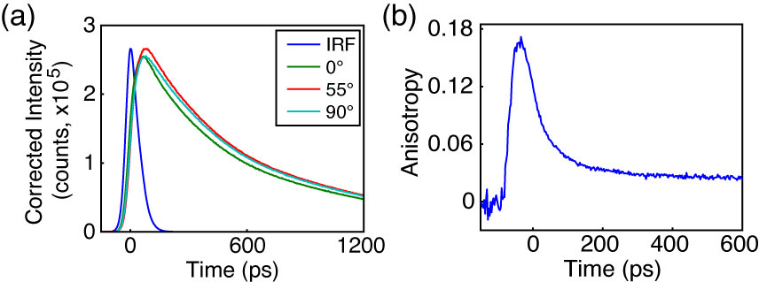

**Fig. 7.** Anisotropy data for PFBT in 40% THF. (a) Intensity decays collected at 0° (green), 55° (red), and 90° (cyan) polarizer orientations with sample IRF (blue). (b) Anisotropy decay *r*(*t*) constructed from intensity data in (a).

**Picosecond Fluorescence Anisotropy Decay (FAD).** Polarized intensity decays collected at 0°, 90° and 55° to the vertically polarized excitation pulse were obtained via reverse-mode TCSPC (c.f. Fig 7a). The resulting polarized intensity data was utilized to construct time-resolved anisotropy decays by the relation , where , , and G is a correction factor accounting for differences in detector sensitivity to vertically and horizontally polarized light (c.f. Fig 7b). The process by which the anisotropy data is calculated from the fluorescence intensity decays at each polarizer orientation was adapted from a method by Fleming et al., and is outlined in detail in the Supporting Information.36

While complete anisotropy data was unable to be obtained for all except MEH-PPV in solution (*r*0 = 0.07 r = 293 ps), anisotropy data for PFBT is given in Fig. 7. For 40%, 60%, 95% and 100% THF, the calculated *r*0 values are 0.18, 0.08, 0.07 and 0.09, and the phenomenological rotational correlation times (r), are 21 ps, 452 ps, 910 ps, and 920 ps, respectively. The increasing correlation times indicate that anisotropy decays more slowly as THF concentration increases. This is expected due to a reduction in exciton diffusion as the interchromophore distance increases due to swelling. The low (~2x to ~50x lower than the theoretical maximum of 0.4) limiting anisotropy values obtained for PFBT suggest that there is more anisotropy information at earlier times, below the time resolution of our instrument. Using the ratio of fluorescence lifetime to rotational correlation time, we can obtain an estimate of the number of exciton hops that occur within the mean exciton lifetime.34 For the case of PFBT CPNs in 40% THF (given that more anisotropy is observed for this sample), the exciton lifetime is ~650 ps, and r is 21 ps. This corresponds to approximately 32 hops within the lifetime of each exciton. Compared to the free polymer in THF, with exp ~2800 ps and r ~900 ps, this corresponds to ~3 hops per lifetime, which suggests that exciton diffusion is favored in the aggregated state.

In order to provide a rough estimate of the correlation time for the CPNs in water, the approximate r was calculated from the model hopping probabilities from the relation , where *khop* is the hopping rate constant. The hopping rate constant can be approximated after Taylor expansion of the exponential term as , and. The results of these calculations yield correlation times of ~5 ps for MEH-PPV CPNs and ~90 ps for PFBT CPNs. While this result is in contrast to the experimental data for PFBT, yielding ~3 hops per lifetime for the CPNs, it is particularly interesting for the case of MEH-PPV CPNs, in that the ratio of lifetime to correlation time yields ~60 hops per lifetime for MEH-PPV CPNs, compared to ~1 hop per lifetime in solution. For both cases, however, this indicates that the hopping rate to six nearest neighbors (for the nanoparticles) is between ~10x and ~60x faster than the hopping rate to two nearest neighbors (for a linear polymer in solution).

Looking at the rate data from the model in conjunction with the experimental anisotropy data for both polymers, further speculation could be made that many of the observed photophysics for both polymers are dictacted by the hopping rates. The data for MEH-PPV indicates that the hopping rate of MEH-PPV is significantly higher as compared to PFBT. It is possible that perhaps MEH-PPV is a better exciton transport polymer than PFBT, which would make it more useful for device applications requiring enhanced transport. In addition, this could lead to difficulty in accurate determination of the defect-free exciton diffusion length for polymers such as this, since past a certain threshold, the exciton motion is limited by the defect concentration, and effectively, the distance between quenchers becomes the exciton diffusion length.

Conversely, the hopping rates could provide some explanation for the significantly poorer quantum yield of MEH-PPV as compared to PFBT, which would make PFBT more useful for applications requiring more photons per unit time. Given that the model results yield approximately the same number of quenchers per unit volume of polymer, it follows that if exciton transport is faster, then excitons would be more efficiently funneled to defect sites, reducing the number of emission events. Thus, even though similar behavior is exhibited with regard to quenching efficiency as we move from a 3D particle to 1D chains through swelling, we still see significant differences in other photophysical parameters between the two polymers such as lifetime dynamics and quantum yield.

**CONCLUSION**

The effect of solvent-induced swelling on various photophysical phenomena within conjugated polymer nanoparticles was assessed by steady-state and time-resolved spectroscopies. Time-resolved fluorescence anisotropy decay along with a discrete lattice model was utilized to probe the rates of exciton hopping. The quantum yield of both systems increases with increasing THF concentration, eventually reproducing the quantum yield for free polymer at 95% THF. Spectral data of MEH-PPV exhibits a significant blue shifted component to the spectra as THF concentration increases, with an approximate isosbestic point between the nanoparticle and free polymer spectra at 580 nm, between 40% and 80% THF. Bi-exponential lifetime data suggests an isosbestic point of 80% for PFBT, and 40% for MEH-PPV. An exciton diffusion, energy transfer model on a discrete cubic lattice yielded 9 and 10 quenchers/particle for PFBT and MEH-PPV respectively, with good agreement to experimental data at low to mid THF concentrations. These data, combined with time-resolved fluorescence anisotropy decay analysis allowed for the determination of the number of exciton hops per lifetime of ~32 for swelled PFBT CPNs and ~3 hops for PFBT in THF. Calculations assessing the effect of dimensionality on quenching efficiency yield an order of magnitude difference in quenching for the 1D and 3D cases. Hopping rates calculated from both anisotropy and model data suggest that the exciton hopping rate is 10-60 times faster in CPNs compared to the polymer in good solvent, which has meaningful implications for imaging and device applications.

**ACKNOWLEDGMENTS**

We acknowledge financial support from the NSF under Grant No. CHE-1058885.

**REFERENCES**

(1) Dennler, G., and Sariciftci, N. S. Flexible Conjugated Polymer-Based Plastic Solar Cells: From Basics to Applications. *Proc. IEEE* **2005**, *93*, 1429-1439.

(2) Yim, K. H., Zheng, Z., Liang, Z., Friend, R. H., Huck, W. T. S., and Kim, J. S. Efficient Conjugated-Polymer Optoelectronic Devices Fabricated by Thin-Film Transfer-Printing Technique. *Adv Funct Mater* **2008**, *18*, 1012-1019.

(3) Wu, C. F.; Szymanski, C.; Cain, Z.; McNeill, J. Conjugated Polymer Dots for Multiphoton Fluorescence Imaging. *J. Am. Chem. Soc.* **2007**, *129*, 12904-12905.

(4) Yu, J., Wu, C. F., Sahu, S. P., Fernando, L. P., Szymanski, C., and McNeill, J. Nanoscale 3D Tracking with Conjugated Polymer Nanoparticles. *J. Am. Chem. Soc.* **2009**, *131*, 18410-18414.

(5) Wu, C. F., Bull, B. Christensen, K. and McNeill, J. Ratiometric Single-Nanoparticle Oxygen Sensors for Biological Imaging. *Angew. Chem., Int. Ed.* **2009**, *48*, 2741-2745.

(6) Wu, C. F.; Bull, B.; Szymanski, C.; Christensen, K.; McNeill, J. Multicolor Conjugated Polymer Dots for Biological Fluorescence Imaging. *ACS Nano* **2008**, *2*, 2415-2423.

(7) Wu, C. F.; Schneider, T.; Zeigler, M.; Yu, J. B.; Schiro, P. G.; Burnham, D. R.; McNeill, J. D.; Chiu, D. T. Bioconjugation of Ultrabright Semiconducting Polymer Dots for Specific Cellular Targeting. *J. Am. Chem. Soc.* **2010**, *132*, 15410-15417.

(8) Wu, C. F.; Chiu, D. T. Highly Fluorescent Semiconducting Polymer Dots for Biology and Medicine. *Angew. Chem., Int. Ed.* **2013**, *52*, 3086-3109.

(9) Koner, A. L.; Krndija, D.; Hou, Q.; Sherratt, D. J.; Howarth, M. Hydroxy-Terminated Conjugated Polymer Nanoparticles Have Near-Unity Bright Fraction and Reveal Cholesterol-Dependence of IGF1R Nanodomains. *ACS Nano* **2013**, *7*, 1137-1144.

(10) Denis, J. C.; Schumacher, S.; Galbraith, I. Quantitative description of interactions between linear organic chromophores. *J. Chem. Phys.* **2012**, *137*.

(11) Hayden, G. W.; Mele, E. J. Correlation-Effects and Excited-States in Conjugated Polymers. *Phys. Rev. B* **1986**, *34*, 5484-5497.

(12) Read, N.; Sachdev, S.; Ye, J. Landau Theory of Quantum Spin-Glasses of Rotors and Ising Spins. *Phys. Rev. B* **1995**, *52*, 384-410.

(13) Avgin, I.; Huber, D. L. Amplitude scaling behavior of band center states of Frenkel exciton chains with correlated off-diagonal disorder. *J. Lumin.* **2008**, *128*, 1623-1628.

(14) Kasha, M.; Rawls, H. R.; Ashraf El-Bayoumi, M. The Exciton Model in Molecular Spectroscopy. *Pure and Applied Chemistry* **1965**, *11*, 371-392.

(15) Emelianova, E. V., Athanasopoulos, S., Silbey, R. J., and Beljonne, D. 2D Excitons as Primary Energy Carriers in Organic Crystals: The Case of Oligoacenes. *Phys. Rev. Lett.* **2010**, *104*, 206405-206408.

(16) Burkalov, V. M., Kawata, K., Assender, H. E., Briggs, G. A. D., Ruseckas, A., and Samuel, I. D. W. Discrete Hopping Model of Exciton Transport in Disordered Media. *Phys. Rev. B* **2005**, *72*, 075206-075210.

(17) Lunt, R. R., Giebink, N. C., Belak, A. A., Benzinger, J. B., and Forrest, S. R. Exciton Diffusion Lengths of Organic Semiconductor Thin Films Measured by Spectrally Resolved Photoluminescence Quenching. *J. Appl. Phys.* **2009**, *105*, 053711-053717.

(18) Gammill, L. S.; Powell, R. C. Energy-Transfer in Perylene Doped Anthracene-Crystals. *Mol. Cryst. Liq. Cryst.* **1974**, *25*, 123-130.

(19) Powell, R. C.; Kepler, R. G. Evidence for Long-Range Exciton-Impurity Interaction in Tetracene-Doped Anthracene Crystals. *Phys. Rev. Lett.* **1969**, *22*, 636-639.

(20) Athanasopoulos, S.; Hoffman, S. T.; Bassler, H.; Kohler, A.; Beljonne, D. To Hop or Not to Hop? Understanding the Temperature Dependence of Spectral Diffusion in Organic Semiconductors. *J. Phys. Chem. Lett.* **2013**, *4*, 1694-1700.

(21) Scholes, G. D., and Rumbles, G. Excitons in Nanoscale Systems. *Nature Materials* **2006**, *5*, 683-696.

(22) Groff, L. C.; Wang, X. L.; McNeill, J. D. Measurement of Exciton Transport in Conjugated Polymer Nanoparticles. *J. PHys. Chem. C* **2013**, *117*, 25748-25755.

(23) Wang, X. L.; Groff, L. C.; McNeill, J. D. Photoactivation and Saturated Emission in Blended Conjugated Polymer Nanoparticles. *Langmuir* **2013**, *29*, 13925-13931.

(24) Sun, K.; Chen, H.; Wang, L.; Yin, S.; Wang, H.; Xu, G.; Chen, D.; Zhang, X. J.; Wu, C. F.; Qin, W. P. Size Dependent Property and Cell Labeling of Semiconducting Polymer Dots. *ACS Appl. Mater. Interf.* **2014**, *In Press*.

(25) Jelly, E. E. Molecular, Nematic and Crystal States of I: I-Diethyl--Cyanine Chloride. *Nature (London)* **1936**, *139*, 631-632.

(26) Hayer, A., Van Regemorter, T., Höfer, B., Mak, C. S. K., Beljonne, D., and Köhler, A. On the Formation Mechanism for Electrically Generated Exciplexes in a Carbazole-Pyridine Copolymer. *J. Polym. Sci. Part B: Polym. Phys.* **2012**, *50*, 361-369.

(27) McNeill, J. D.; Barbara, P. F. NSOM Investigation of Carrier Generation, Recombination, and Drift in a Conjugated Polymer. *J. PHys. Chem. B* **2002**, *106*, 4632-4639.

(28) Hintschich, S. I.; Rothe, C.; Sinha, S.; Monkman, A. P.; de Freitas, P. S.; Scherf, U. Population and Decay of Keto States in Conjugated Polymers. *J. Chem. Phys.* **2003**, *119*, 12017-12022.

(29) Wu, C. F., Peng, H., Jiang, Y. and McNeill, J. Energy Transfer Mediated Fluorescence from Blended Conjugated Polymer Nanoparticles. *J. PHys. Chem. B* **2006**, *110*, 14148-14154.

(30) Wu, C. F., Zheng, Y. L., Szymanski, C., and McNeill, J. Energy Transfer in a Nanoscale Multichromophoric System: Fluorescent Dye-Doped Conjugated Polymer Nanoparticles. *J. PHys. Chem. C* **2008**, *112*, 1772-1781.

(31) Yang, Z.; Huck, W. T. S.; Clarke, S. M.; Tajbakhsh, A. R.; Terentjev, E. M. Shape-Memory Nanoparticles from Inherently Non-Spherical Polymer Colloids. *Nature Materials* **2005**, *4*, 486-490.

(32) Schaffer, J.; Volkmer, A.; Eggeling, C.; Subramaniam, V.; Striker, G.; Seidel, C. A. M. Identification of single molecules in aqueous solution by time-resolved fluorescence anisotropy. *J. Phys. Chem. A* **1999**, *103*, 331-336.

(33) Broos, J.; Visser, A. J. W. G.; Engbersen, J. F. J.; Verboom, W.; vanHoek, A.; Reinhoudt, D. N. Flexibility of enzymes suspended in organic solvents probed by time-resolved fluorescence anisotropy. Evidence that enzyme activity and enantioselectivity are directly related to enzyme flexibility. *J. Am. Chem. Soc.* **1995**, *117*, 12657-12663.

(34) Martini, M.; Roux, S.; Montagna, M.; Pansu, R.; Julien, C.; Tillement, O.; Perriat, P. How gold inclusions increase the rate of fluorescein energy homotransfer in silica beads. *Chem Phys Lett* **2010**, *490*, 72-75.

(35) Szymanski, C., Wu, C. F., Hooper, J., Salazar, M. A., Perdomo, A., Dukes, A., and McNeill, J. Single Molecule Nanoparticles of the Conjugated Polymer MEH-PPV, Preparation and Characterization by Near-Field Scanning Optical Microscopy. *J. PHys. Chem. B* **2005**, *109*, 8543-8546.

(36) Cross, A. J.; Fleming, G. R. Analysis of Time-Resolved Fluorescence Anisotropy Decays. *Biophys J* **1984**, *46*, 45-56.

(37) Chen, R. Apparent Stretched-Exponential Luminescence Decay in Crystalline Solids. *J. Lumin.* **2003**, *102*, 510-518.

(38) Yu, J., Wu, C. F., Tian, Z. and McNeill, J. Tracking of Single Charge Carriers in a Conjugated Polymer Nanoparticle. *Nano Lett.* **2012**, *12*, 1300-1306.

(39) Lee, J. H.; Gomez, I. J.; Sitterle, V. B.; Meredith, J. C. Dye-labeled polystyrene latex microspheres prepared via a combined swelling-diffusion technique. *J Colloid Interf Sci* **2011**, *363*, 137-144.